**Assignment 8.3**

**Transactions in Hive**

Row-level Transactions Available in Hive 0.14

Transaction features present in Hive needs to be turned on, as by default they are turned off

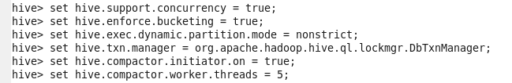

**Creating a Table that supports Hive transactions:**



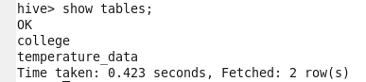

Successfully created a table named ‘college’ which supports row-level transactions of Hive

**Inserting Data into a Hive Table:**

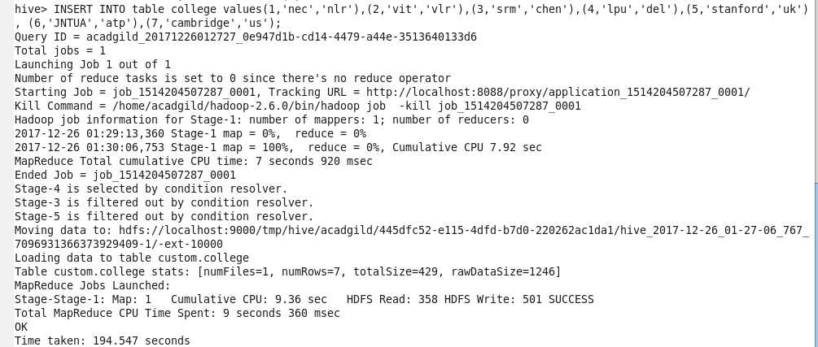

Successfully inserted data into Hive table

The contents of the table can be viewed using the command **select * from college**

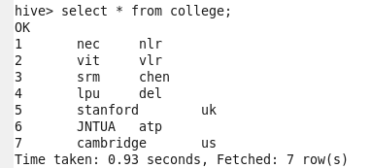

Data has been inserted successfully into the table

**Now trying to re-insert the same data again, it will be appended to the previous data as shown below:**

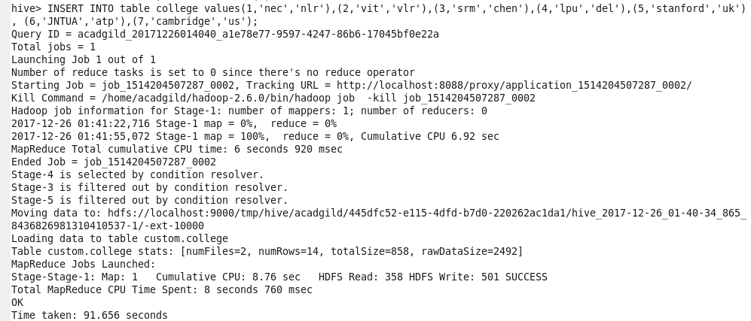

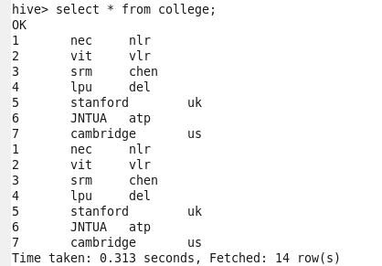

**Updating the data in Hive table:**



**Above error is thrown since we are trying to perform UPDATE operation on bucketed column**

**Now let’s perform UPDATE operation on non-bucketed column:**

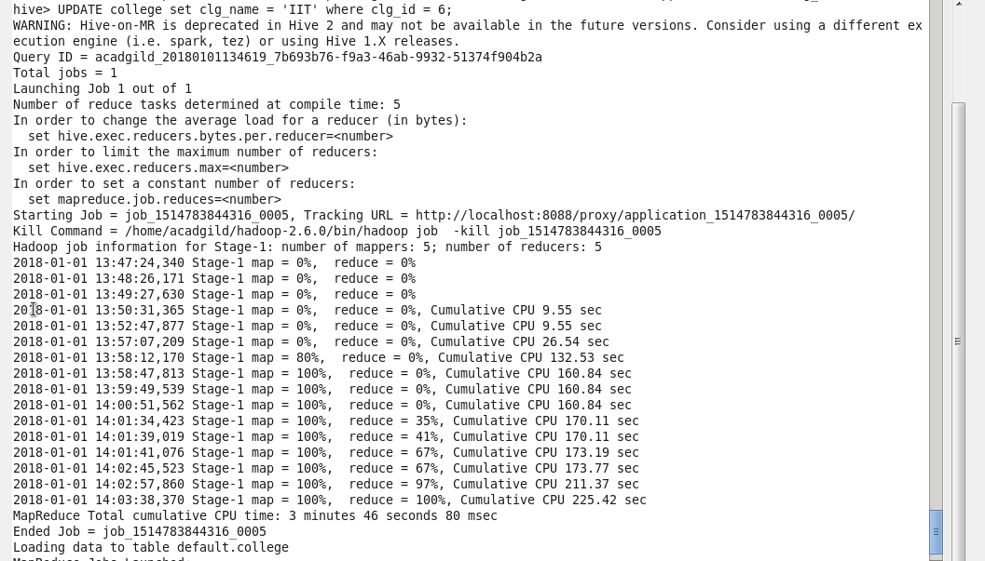

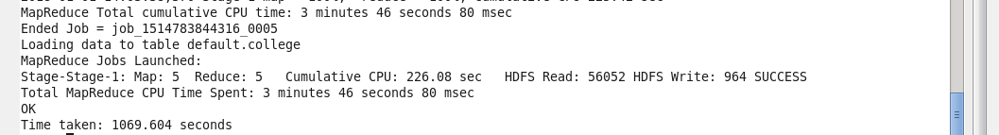

**Successfully updated the data**

**It can be observed that records with clg_id = 6 is updated, clg_name is the updated column**

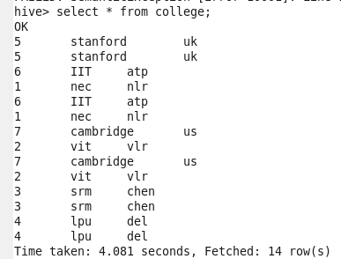

**Deleting a row from Hive table**

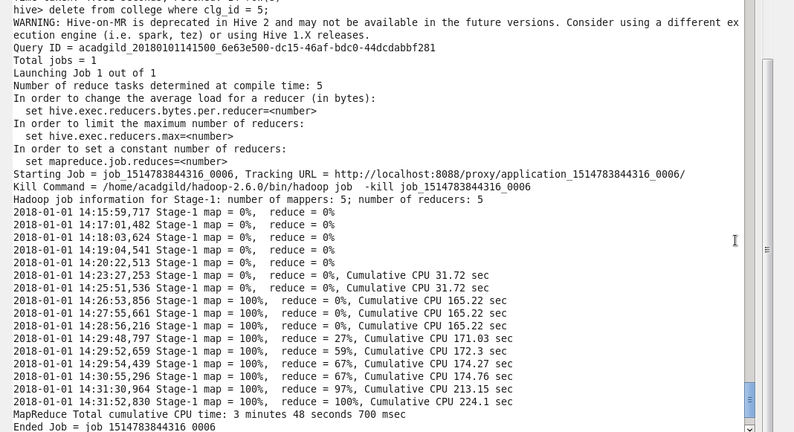

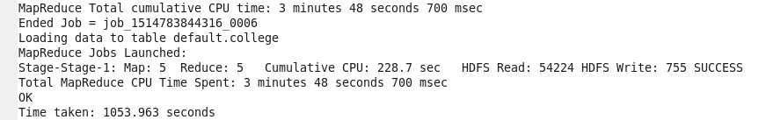

**Successfully deleted a record with clg_id =5, let’s check the same using below command:**

